# OPTIMIZATION OF SOFTWARE ESTIMATION

***Submitted in fulfillment for the award of the degree of***

 ***BACHELOR OF TECHONOLOGY (B.TECH)***

**Department of Computer Science**

**Faculty of Engineering and Technology**

**Agra College,Agra**

**2018-2019**

**(Affiliated to Dr. A.P.J .Abdul Kalam Technical University, Lucknow)**

**Mentor:**

Dr. R.K Sharma

Professor

Computer Science & Engineering

**Submitted By:**

|  |  |  |  |  |  |  |
| --- | --- | --- | --- | --- | --- | --- |
| **Ayush Dubey** | | **Akash Rathore** | **Hardik Chaturvedi** | **Chetan Tiwari** | **Abhishek Singh** | |
| **(1500210026)** | **(1500210007)** | | **(1500210039)** | **(1500210029)** | | **(1500210002)** |

# Department of Computer Science & Engineering



**CERTIFICATE**

This is to certify that Mr. Hardik Chaturvedi (1500210039) , Mr. Ayush Dubey (1500210026),Mr.Akash Rathore(1500210007), Mr.Chetan Kr. Tiwari (1500210029), Mr. Abhishek Singh(1500210002) and have successfully completed the project work entited­.

**“Optimization Of Software Estimation”**

Partially fulfillment of the requirement for the award of the Degree of Bachelor of Technology in Computer Science & Engineering by the **Dr. A.P.J Abdul Kalam Technical University** Lucknow during the academic year (2018-2019).

**Project Guide**

**Dr. R. K. Sharma**

**(Dept. of Computer Science and Engineering)**

# ACKNOWLEDGEMENT

Any software project is not the work of single individual. It combines the efforts Idea suggestion review and hard work.

We express our heartfelt gratitude to all those who contributed in the Successful completion of our project a sincere thanks to our mentor **Dr. R. K. Sharma** (faculty of engineering science & engineering department F.E.T Agra College, Agra) for allowing us to carry out the project and for providing us with useful information and important ideas at different instances throughout the project.

We take the opportunity to thank our family and friends who have a source of impression for making us read the right path. We are greatly indebted tour all the lectures in computer science department for many useful and valuable information which they give while bringing out this project us

Hardik Chaturvedi (1500210039)

Ayush Dubey (1500210026)

Akash Rathore (1500210007)

Abhishek Singh (1500210002)

Chetan kr Tiwari (1500210029)

# ABSTRACT

Software cost estimation is a challenging and onerous task. Estimation by analogy is one of the expedient techniques in software effort estimation field. However, the methodology utilized for the estimation of software effort by analogy is not able to handle the categorical data in an explicit and precise manner.

The software development accurate cost estimation, size, effort, and schedule is probably the biggest challenge facing software developers today. One of the most dominant and serious complaints arising from the "software crisis" is the inability to estimate with acceptable accuracy the cost, resources, and schedule required for a software development. Traditional intuitive estimation methods have consistently produced optimistic results which contribute to the too familiar cost overrun and schedule slippage. It is observed that different methods give different results for the same inputs because many intangible of historical data and every software project will have its unique features and cannot be compared with future projects. Experts suggest using more than one estimation method and analyzing the results before making a decision. An accurate estimate of software size is an essential element in the calculation of estimated project costs and schedules. The fact that these estimates are required very early on in the project (often while a contract bid is being prepared) own makes size estimation a formidable task size lies between 2-50 KLOC. In this paper we have applied the linear regression model to predict the software project effort and functions point, and on the basis of the fuzzy logic we have also predicted the software project effort.

Managing cost estimation operation is more challenging than it appears. A Cost Estimation generally, relies on practically-based system and this project is not manually worked flow. However, such system soon meets its limitations. This is mainly because individuals in the system review have been limited capability to handle massive information flow when the project is at peak capacity.

Consequence, every projects have worked on computerized easily find out the specific cost of any project what is the actual cost are used in a project. This project seeks to research, develop and experimentally implement and validate a computerized cost estimation system to replace error prone and monotonous paper-based systems. The project proposed a Web Application Review System (WARS) to handle estimation Operation such as error handling, in between Actual KLOC and original KLOC.

The cost of each item of work is worked out from the quantities that already computed in the detailed measurement form at workable rate. But the total cost is worked out in the prescribed form is known as abstract of estimated form. 4%of estimated Cost is allowed for Petty Supervision, contingencies and unforeseen items.

* **Quantity of materials & cost:** The requirement of materials is taken strictly in accordance with standard data book (S.D.B).The cost of these includes first cost, freight, insurance and transportation charges.
* **Cost of labor:** The exact number of laborer’s required for unit of work and the multiplied by the wages/ day to get of labor for unit item work.
* **Cost of equipment (T&P):** Some works need special type of equipment, tools and plant. In such case, an amount of 1 to 2% of estimated cost is provided.
* **Overhead charges:**To meet expenses of office rent, depreciation of equipment salaries of staff postage, lighting an amount of 4% of estimate cost is allocated.

A sequence of software prototypes were developed after extensive researches, design, implementation and testing phases were conduct sequentially. The final prototype satisfied most of the high priority and non-functional requirements. Many subsequent features were integrated into the prototypes as the projects as the project evolved.

They were each tested and validated in order to demonstrate their capabilities to fulfill the project’s objectives. All these processes are managed by agile methodology and involved Continuous Integration for software source control and test automation.

We are using following models:-

* **Basic COCOMO**
* **Intermediate COCOMO**
* **Bailey Model**
* **Doty Model**
* **Halstead Model**
* **Fuzzy Model (**Developed by own Method**)**

**Introduction**

## INTRODUCTION

Estimating the work-effort and the schedule required to develop and/or maintain a software system is one of the most critical activities in managing software projects. The task is known as Software Cost Estimation. Fuzzy Approach gives flexibility in application and gives near accurate efforts. During the development process cost and time estimates are useful for the initial rough validation and monitoring of the project’s progress.

## PROJECT BACKGROUND

The use of computers and computing technology within the Department of Defense continues to grow at an accelerating rate. As the use of computers has expanded, so has the need for computer software. While computer hardware has decreased in cost relative to its performance, the cost of software continues to increase. It is estimated that the Department of Defense spends approximately thirty billion dollars annually in the acquisition and maintenance of software (Boehm, 1987). Virtually no area within the military has escaped the "software invasion." From the million-plus lines of code for the Sea wolf computer system to the two million lines of code in the Navy's NALCOMIS Phase HI logistics system, software is now one of the submarine's BSY-2 driving factors in the success of the United States military.

Although the technology used to develop software has improved through the use of such methods as object-oriented programming and computer-aided software engineering (CASE), one software management area which remains underdeveloped is software cost estimation. Since the greatest expense in a software development effort is manpower, software cost estimation models focus on estimating the effort required to complete a particular project. This estimate of effort required can then be translated into dollars using the appropriate labor rates. The current cost estimation models available to software project managers fail to provide sound estimates in a consistent manner, even within their own narrowly defined domains. Improper estimation of costs is a major reason why many Department of Defense software projects have failed. With a decreasing budget for defense, it is of even greater necessity that managers have available to them effective software cost estimation tools. There are many models available for software cost estimation. One of the more popular models is the Constructive Cost Model, or COCOMO, developed Barry Boehm while at TRW (Boehm, 1981). This model is based database of sixty-three projects developed at TRW during the 1960's and 1970s and is described in detail in Boehm's book, Software Engineering Economics. Part of the reason for the popularity of COCOMO is that it is relatively easy to apply and it resides in the public domain. Other models, such as ESTIMACs, developed by Howard Rubin and currently the property of Computer Associates, Inc, are proprietary due to the nature of the project data from which they were developed. A common thread that exists in all of these models is that they were developed by domain experts and are heavily dependent upon the judgment of the expert for the determination of the model inputs and relationships extracted from the software project data.

An alternative approach to model development that can reduce the need for the domain expert to act solely on judgement is through the use of artificial intelligence , While artificial intelligence has been a subject of study since the 1950's, it has periodically been the skepticism for a perceived inability to deliver at the level of performance promised by its proponents. In recent years, 2 as both computer hardware and software have grown more powerful and the objectives of **AI** been better defined, the **field** of artificial intelligence has see resurgence.

## 1.2 Project Content

Estimation tools may be stand-alone products or may be integrated into the functionality of larger project management products. Estimation tools may just support the size estimation process, or just the conversion of size to effort, schedule and cost, or both. Project management tools have been discussed in an earlier ADS newsletter (November 1997). Tools that support just size estimation include LOC counters, Function Point analysis programs, and even requirements capture and management applications. This section of this report just focuses on estimation tools that are stand-alone products and support the conversion of size to effort etc.

No estimation tool is the “silver bullet” for solving your estimation problems. They can be very useful items in your estimation toolkit, and you should seriously consider using one (or more), but their output is only as good as the inputs they are given and they require you to have an estimation and software development process in place to support them. Beware of any vendor claiming their tool is able to produce estimates within +/- some small percentage of actual unless they also highlight all the things you must be able to do in a predictable manner and what must go right during a project to ensure an estimate can be that accurate.

## 1.3 Project Motivation

IT has become important tools to support business operations. Especially the estimate project IT is playing increasingly important roles in resources administration, managing services, and assisting strategic decision making several and research worked. Accurate software cost estimation in project is important to develop a reliable software system. Underestimating a project contributes to

* Under-staffing it (resulting within staff burnout).
* Under-scoping the coffee quality assurance hard work (running raise the risk of inferior deliverables), and location too quick a plan (resulting in decrease of credibility since deadlines usually are missed).
* Over-estimating a project will
* Cost greater than it need to (a negative affect the underside line).
* Take longer to deliver than needed (resulting within lost opportunities
* Delay the application of your resources on the next undertaking.

## 1.4 Project Objectives

As discussed above, when a software project is late and over-budget in providing the expected results, the problem may lie in the inadequacy of either the management process or of the resource assignment process. Determining whether either of or both these possibilities are true is always an extremely difficult operation. Certainly, there are many collateral indicators that can provide helpful hints as to the quality of the management process and the estimation capacity. For example, the use of advanced project management techniques and methods, the use of standards, or the level of group motivation may provide indications as to management quality, while the use of modeling consolidated in the technical literature, or of tools of a proven effectiveness calibrated on reliable benchmarking databases may be able to suggest the level of quality of the estimation process. These indicators may swing the needle of the scale from one side to the other, but the question as to what the cause and effect may be of not complying with the resource constraints tends to look too much like a loop: a project with few assigned resources tends to overheat just like an out-of-phase engine, and this tends to lead to abandoning mature labor practices and standards in favor of approximating activism and anxious attitudes which, in turn, tend to waste human resources. The project gets increasingly close to the point of no return, where everyone tries to abandon ship while there is still time to do so with honour. The same thing may happen if, vice versa, resources are sufficient but the project is poorly managed.

The so overheating spiral described above is triggered ns soon as the project's "The reserves are consumed without producing appreciable results. This behavior is all too frequent, as shown by the project accounts discussed in the statistics gathered in the field. Therefore, to reduce the risks of failure due to these causes, it is necessary to act to improve the systems and capacities of both project management and of quantitative estimation; the latter is an important subset of the former.

Effective software project estimation is one of the most important activities in software development. Estimation is one of the cornerstones of effective project planning: effective project planning and control is not possible without a sound and reliable estimate. In recent SPC surveys ( source : SPC Direct Insights webinar series ) only 18 % of software professionals identified estimation as a key strength or their organization , while 70-90 % of those surveyed experienced financial impacts on their businesses, lost competitive advantage, and delays in

getting benefit from their plans and initiatives due to bad estimates. Even today it is clear that the software industry in general doesn't estimate projects well and doesn't use estimates appropriately. We suffer far more than we should as a result and we need to focus some effort on improving the situation. Under-estimating a project leads to under-staffing it (which often results in staff burnout), under scoping the quality assurance effort (running the risk of low quality deliverables), and setting too short a schedule (resulting in loss of credibility as deadlines are missed). For those who figure on avoiding this situation by generously padding the estimate, overestimating a project can be just as bad for the organization! If you give a project more resources than it really needs without sufficient scope controls it will use them up! This is known as Parkinson's Law: "Work expands so as to fill the time available for its completion".

The project is then likely to cost more than it should (a negative impact on the bottom line), take longer to deliver than necessary (resulting in lost opportunities), and delay the use of your resources on the next project. Neural network theory grew out of Artificial Intelligence research, or the research in designing machines with cognitive ability. A neural network is a computer program or hardwired machine that is designed to learn in a manner similar to the human brain. Haykin (1994) describes neural networks as an adaptive machine or more specifically:

A neural network is a massively parallel distributed processor that has a natural propensity for storing experiential knowledge and making it available for use. It resembles the brain in two respects: Knowledge is acquired by the network through a learning process and interneuron connection strengths known as synaptic weights are used to store the knowledge.

The basic building block of a brain and the neural network is the neuron. The basic human neuron adapted from Beale and Jackson (1990) is shown below in Figure 1

**The Research Question**

The primary research question of this thesis is to determine the feasibility plying machine learning to the problem of software cost estimation. This search uses the COCOMO data set for model training and the COCOMO, the important questions of this thesis are to determine the effectiveness of machine-learning techniques when applied to the cost estimation problem and what insight, if any, can be gained from the machine generated models into estimation.

**Requirements**

## 

## REQUIREMENTS

## Requirement Specification

Requirement specification aims to define requirements in clear and unambiguous language based on requirement identified during requirement elicitation and requirement analysts. The requirement are evolved over time and become more accurately reflect the needs of the stakeholders. The next steps are to document these requirements and treat them as ultimate references of domain knowledge and business rules. Document requirement can be challenging, and it is aligned to the fact that the software industry appeared to use the term “requirement” inconsistently .Requirement could be a high-level abstract description of system provided services, or comprehensive formal definition of system functional units. Given the vast different of stakeholder’s perspectives and interests about the best way of specifying requirements, a further investigation into approaches of documenting requirements is necessary. Requirement document-known as software requirement specification (SRS), contain important statement describing the software product to be built. The level of details may vary depending on the type of developing system. Safety critical and complex systems often require detailed description of constraints or essential domain knowledge. On the other hand, requirements for commercial software are often changing and become out-of-date quickly. It appears that use case and story card from agile development methods are more flexible in capturing business requirements.

1. Focus on software, not documentation: Create it only if it is essential to the work effect.
2. Keep it simple: Create the most minimalist version of each artifact and use simple tools such as index cards.
3. Proceed iteratively: Start by identifying a high-level model and gather the details as the work process; and

Work as Team. Close collaboration could improve communication thus reduce need for documentation. Following on from this, the next steps are looking at two major categories of requirements.

## Functional Requirement (FR)

Functional requirement describe the features that the system has to provide. It often describe the expected features the user can utilize to perform their task. It may cover certain business processes and procedures that the software must follow and perform to achieve user goals – sometimes termed business logic. Thus, FRs often associated with desired behavior characteristics of developing software to produce the expected result. The primary FRs of the WARS is to support or assist restaurant workers in the process or Management of the food-ordering workflow.

## Non-functional Requirement (NFR)

Non-functional requirements refer to characteristics and constraints with which the system must comply. It concerned with quality aspects of software system and good user experience such as performance, security, availability. Unlike FR, NFR does not usually related to functionality that yields operation results directly. However, NFR do affect the experience or result quality when the user using the system. This is pointed out by that:

“NFR may affect the overall architecture of a system rather than the individual components.”

Hardware Requirement

|  |  |
| --- | --- |
| **Number** | **Description** |
| 1. | PC with 20 GB Hard disk |
| 2. | PC with 256 MB RAM |
| 3. | PC with Dual core and above |

Software Requirements

|  |  |  |
| --- | --- | --- |
| **Number** | **Description** | **Type** |
| 1 | Operation System | Window 7 to window 10 |
| 2 | Language | PHP Advance |
| 3 | Framework | MVC |
| 4 | Server side Script | PHP script |
| 5 | Client side Script | Java script, html5, j Query, JSON, CSS3 |
| 6 | Server | XAMPP Server |
| 7 | Database | My SQL |

**DESIGN**

**DESIGN**

The design phase is intended to transform the requirements into conceptual solutions that could set a baseline for software implementation. It intends to identify the design solutions. It starts by identifying the design principles of agile development and taking them into heart of design activity. The project will then establish a high-level vision of the developing system through architectural design. It moves on to system modeling to create design models to understand characteristics and constraints of the system.

Goals and Dreams

“The Task”

DESIGN

“The Means”

Materials Tools and Mechanisms

The continuing place of design

## Design Process in Agile Development

Design process in traditional software development follow a series of planned design activities or steps, or phases which produces design models that become guidelines to the developers – for the implementation phase. However, this can conflict with agile methods, as if considering an interesting fact:

“Agile practionersbelieve that design is not only highly iterative, but emergent models often lie. Thus, only coding, running tests, and refactoring the code reveal truth about a design.”

In order to understand this conflict, it explained two styles of design in software development, namely:

1. Planned design, and
2. Evolutionary design.

**Evolutionary design** means the design for a particular system grows as the system is being developed however, evolutionary design is a disaster in common usages because:

* Aggregate of ad-hoc tactical decisions lead to code base that hard to change:
* It leads to poor design when ability to make changes deteriorates; and
* Bugs become exponentially expensive to fix.

In contrast, planned design is closer to the engineering metaphor where designer produces blueprint that consists of fundamental rules and structures to build the software development, yet it has several drawbacks:

* Impossible to think through all the issues and new questions that emerge during programming;
* Technology changes rapidly and initial concept may not match with the latest tools and material; and
* It deals poorly with unforeseen changes of requirements.

The conflict of planned design and evolutionary design is widely known as "code is my design" versus "big design upfront Nevertheless, both design styles may not be ideal to software development due to their problems mentioned above. This was until the emerged of agile methods such as XP that enabled evolutionary design by adopting set of principles to address changes and effects of changes in design. pointed out that the core of enable principle of XP are testing and continuous integration Testing ensures that design decisions and changes are safety verified while continuous integration is essential earn in sync and not worry about new changes will break existing system. In addition to this, described that models reach their point of maximal value when they are barely good enough. This again argues that design does not necessary needs every details been planned.

Design process in WARS attempts to embrace changes with agile methods while important design decisions that could be done with planned modeling. They are described as following:

* Model with a purpose. It is important to know the purposes and for which stakeholder a particular model was intended when creating a model. The model is intended to keep the developer focus on solving particular problems rather than figuring out whether it is sufficiently detailed and accurate.
* Incremental changes. Models do not need and are unlikely to meet all needs when they are first implemented. Modeling should start from high-level.

The clear segregation of their responsibilities results in several benefits:

* The logic of presentation (view) , input (controller) and business process (modal ) could be changed and allowed to evolve independent hence achieving separation of concerns;
* The view is decoupled from the model allowing multiple ways to present the same data that accommodate user concerns; and
* Loose coupling between the view and the controller also enhance the testability of the application.

DATA FLOW DIAGRAMS-

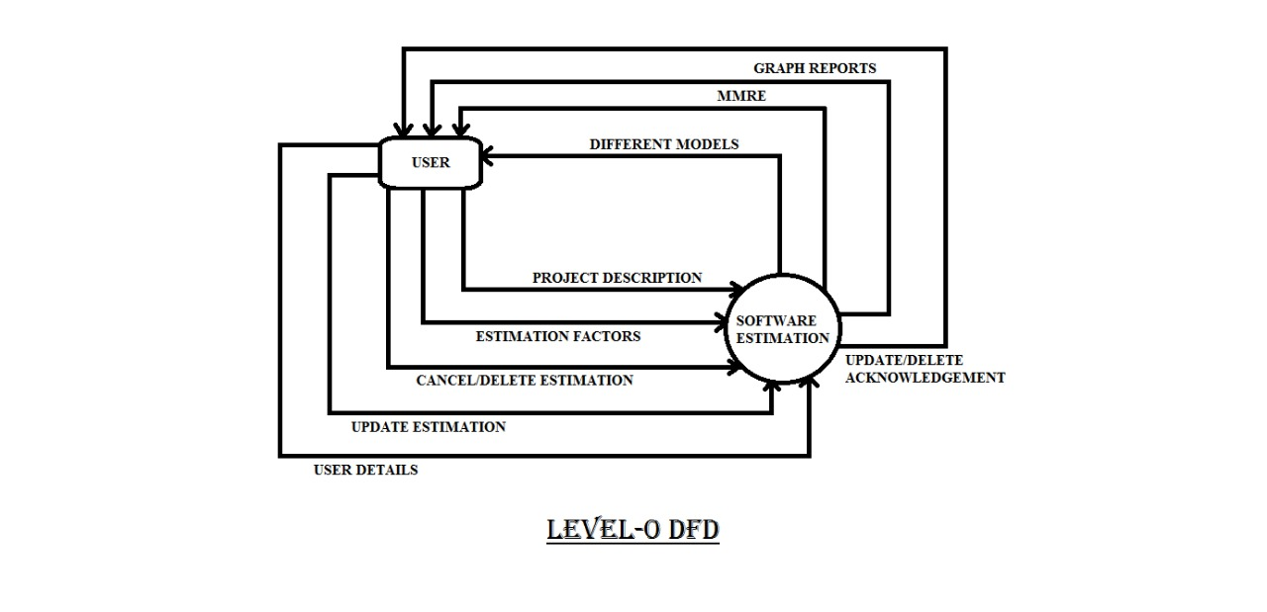

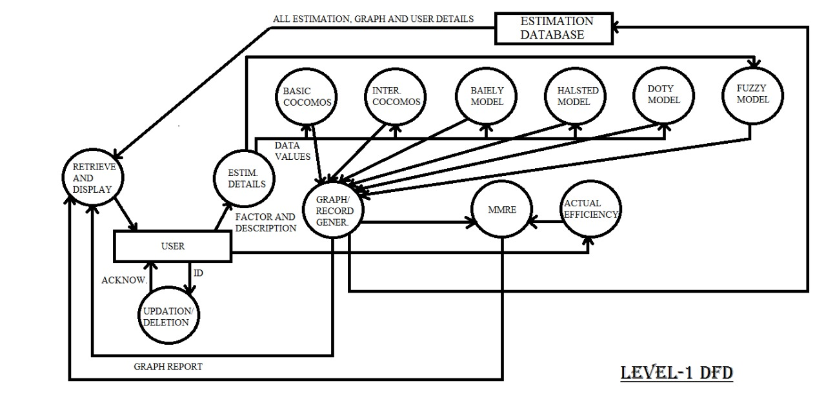

E-R DIAGRAM-

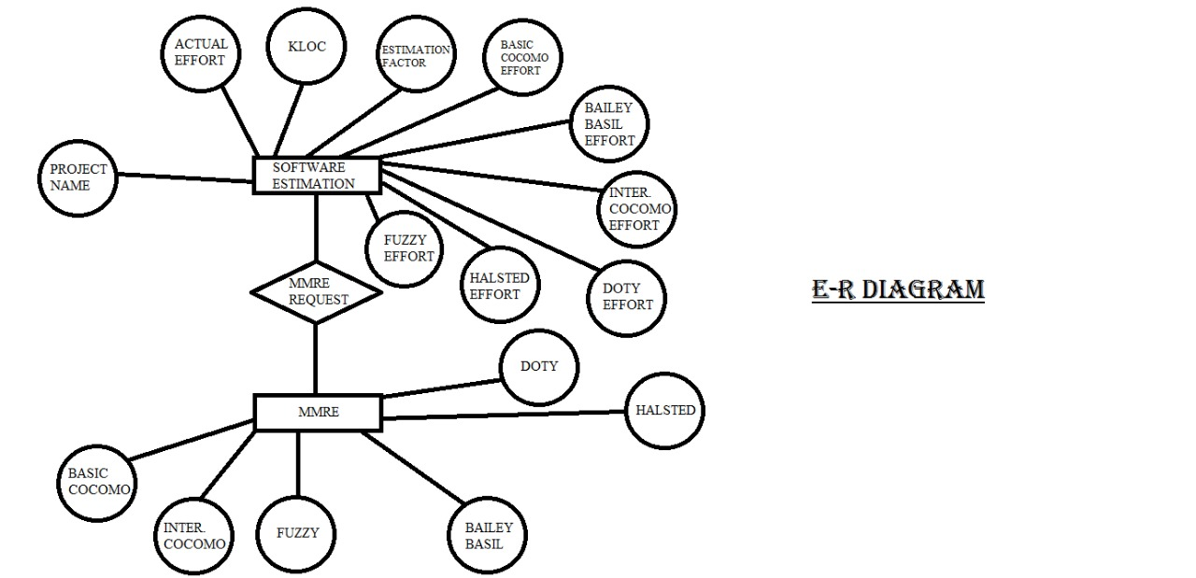

**CODEIGNITER MVC** has a built-in infrastructure to implement the necessary Controller class and construct the view. The user inputs could be viewed as HTTP requests that are sent from client web browser. The framework will route the request based on the request URL to the correct Controller class.

The project’s design evolved into actual implementation by adopting suitable technologies and SE (and HCl) techniques. The utilized technologies and techniques include various: SE methodologies, HCl principles HCI principles, programming tools, frameworks and libraries during the construction the prototype software. Besides making the development process more effectively, they have also improved the quality of system since it is a tested solution.

However, the implementation approaches centered on the web development framework technologies. However, the development process will be accelerated once they understanding the basic concepts of these technologies. The project had adopted different testing approaches to test the prototype software and discovered bugs during these testing were corrected. However, the performance testing done in the project is concerned with general server performance. The testing could also be extended to understand the performance of the java script implementation at the client side. Nevertheless, this largely depend external factors such as devices capabilities and type of web browsers used. Hence, the testing may help in optimizing code efficiency but not aiming to support every possible device with a web browser.

# Model View Controller

Controller

View

Model

Presenter

View

Model

# Model-view-Controller

# Model-View-Controller (MVC)

The Model-View-Controller paradigm provides a way to separate out the components of a user-interface oriented application, allowing each component to specialize and to be developed in relative isolation. The Visual Works user-interface classes are all built around the MVC paradigm, so much of the work has already been done for you. At the micro level, all you really need to do is use the provided classes until you need some specialized functionality.

1. **Model** refers to data and behavior of the application. It is responsible for providing the current state of its data and handle instructions for states change according the client requests;
2. **View** is the user interface that presents the state of data and manages the way they are presented; and
3. **Controller** captures the user inputs from user interface and manages the flows to client requests; presented; and update the model state and view information. value of modeling details and evolve over time in an incremental manner. T should contain just enough details to solve current goals and may require refactoring.

* **Assume simplicity** Modeling should assume the simplest solutions are the best solutions and hence avoid unnecessary efforts spent on features that users do not need or optimizations that are not necessary - or focus on issues that may take long to materialize and are not essential. This is highlighted in the quotations: "Do the Simplest Thing that Could Possibly Work" and "You Aren't Going to Need Io" which are manifestation of Simple Design principle in XP.
* **Working software is your primary goal**. The main objective in software development is to produce high quality software.

# Architecture Design

The design process in WCRS started with an initial architecture software system is described as design. The architecture of software system is described as;

1. “A Formal description of a system or a detailed plan of the o at component level to guide its implementation; and
2. The structure of components, their interrelationships, and the principles and guidelines governing their design and evolution over time”.

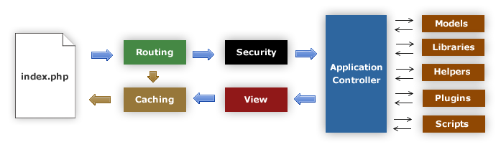

It acts as the important entry point to the design process in software development particularly important in scaling software development as it gradually become large and complex. As the project progresses through the various decision-makings, it needs to be well-established architecture that acts as a baseline to such activities Architecture design also connected to design goal of achieving separation of concern by the decomposition of functional elements into different subgroups The mechanism of decomposition (o division) will affect every functional modules including the structure definition and their interaction.

# Software Architecture

Software architecture could be understood through various definitions.

It as

“The process of defining a structured solution that meets all of the technical and operational requirements, while optimizing common quality attributes such as performance, security and manageability,".

Software architecture by highlighting its important elements, listed as:

l) Highest level breakdown of a system into part;

2) Decisions that hard to change;

3) There are multiple architecture in a system; and

4) What is architecturally significant is one that can change over a system's lifetime.

These definitions mean that the software architecture phase represents the important design decision phase required to build a stable and scalable system. This is crucial for a successful system because it helps to address the quality and risk factors aligned to the project. Moreover, design concerns such as selection of algorithm(s), business logics and data structures often overlap with architecture decisions. Thus, the vision of architecture needs to be established to provide direction of development style.

This project is developing a web application’s hence, the following sections will explore several software architecture styles for web application.

# Data Storage

Data Storage of storage is the container resource for data objects. The data structures that will be step in the system need to be stored with one or more data storage methods. This is investigates two main options of data storage and describes the chosen methods for WCRS.

**Relational Database Management System (RDBMS)**

RDBMS is data-processing software that employs relational model as its fundamental data structures. [61] Describes the relational model as following:

+

“In the relational model, all data is logically structured within relations (tables). Each relation has a name and is made up of named attributes (columns) of data. Each tuple (row) contains one value per attribute."

These have been widely adopted by industry, particularly in small and medium business.

The advantages of RDBMS are:

* Support for controlling concurrency and transactional access;
* Support for security management;
* Minimal data redundancy;
* Simple user interface to manage data schema
* Ensuring data integrity through constraints; and
* Fast data retrieval through query optimization.

**User Interface Design**

This section develops the concepts related with modeling the graphical user interface (GUI) of WCRS. Two important concepts utilized in designing the User lnterface (UI) in WCRS are Hierarchical Task Analysis and Responsive Web Design. The following sections with described how the design concepts contributed to the final design with high fidelity design utilizing wireframe diagrams

When users interact with the system, they are trying to perform actions that could meet their high-level goals or needs. These actions, more appropriately called Tasks, often can be broken down into series of small steps. UI of any system are means to assist users to go through these steps and provide comfortable experience during this process. Hence, the project employs HTA to understand several important tasks that the user is performing. This understanding will lead to design model with appropriate UI elements and behaviors that match user tasks.

SCOPE

The scope of this thesis is to apply the three machine learning techniques to the cost estimation problem using the COCOMO to determine the extent to which they are appropriate and insightful to the cost estimation. This thesis is not to develop a better model for cost estimation but instead to develop a methodology for the application of machine learning to this problem.

**Fuzzy logic**

**&**

**Technique**

FUZZY LOGICS

## HISTORY

Fuzzy logic was introduced in 1965 by Lofti A Zadeh in his paper "Fuzzy Sets". Zadeh and others continued to develop fuzzy logic at that time. The idea of fuzzy sets and fuzzy logic were not accepted well within academic circles because some of the underlying mathematics had not yet been explored. The applications of fuzzy logic were slow to develop because of this, except in the east. In Japan specifically fuzzy logic was fully accepted and implemented in products simply because fuzzy logic worked, regardless of whether mathematicians agreed or not. The success of many fuzzy logic based products in Japan in the early 80s led to a revival in fuzzy logic in the US in the late 80s. Since that time America has been playing catch up with the east in the area of fuzzy logic.

Some of the objections that faced fuzzy logic in its early days are shown below. Note that Professor William Kahan is Lofti Zadeh colleague at UC Most objections to fuzzy logic have since faded due to the success applications.

"Fuzzy theory is wrong, wrong, and pernicious. What we need is more logical thinking, not less. The danger of fuzzy logic is that it will encourage the sort of imprecise thinking that has brought us so much trouble. **Fuzzy logic is the cocaine of science**”

**-Professor William kahan UC Berkeley**

“Fuzzification is a kind of scientific permissiveness. It tends to result in socially appealing slogans unaccompanied by the discipline of hard scientific work and patient observation.”

**-Professor Rudolf Kalian UFlorida**

Fuzziness is probability in disguise. I can design a controller with probability that could do the same thing that you could do with fuzzy logic." -Professor Myron Tribus, on hearing of the fuzzy-logic control of the Sendai subway system IEEE Institute, may 1988. Fuzzy logic, invented by Professor Lofti Zadeh of UC-Berkeley in the mid- 1960s, provides a representation scheme and a calculus for dealing with vague or uncertain concepts. It provides for the facile manipulation of such terms as "large", "warm", and "fast," which can simultaneously be seen to belong partially to two or more different, contradictory sets of values. Zadeh originally devised

the technique as a means for solving problems in the soft sciences, particularly those that involved interactions between humans, and / or between humans and machines. Within the United States, with some exceptions, the technique has remained mainly of basic research interest. The situation in Japan is quite different. Professor Terano, inspired by Zadeh's work, introduced the idea to the Japanese research community in about 1972. Perhaps because of a Japanese cultural view of the vagueness of human nature (all concepts belonging partially to contradictory sets), there was almost Fuzzy set.

## FUZZY SETS

Fuzzy Set Theory was formalized by Professor Lofti Zadeh at the University of California in 1965. What Zadeh proposed is very much a paradigm shift that first gained acceptance in the Far East and irs successful application has ensured its adoption around the world.

A paradigm is a set of rules and regulations which defines boundaries and tells us what do to be successful in solving problems within these boundaries. For example the use of transistors instead of vacuum tubes is a paradigm shift likewise the development of Fuzzy Set Theory from conventional bivalent set theory is a paradigm shift.

Bivalent Set Theory can be somewhat limiting if we wish to describe a **‘humanistic’** problem mathematically. For example, bivalent sets to characterize the temperature of a room.

The obvious limiting feature of bivalent sets that can be seen clearly from the diagram is that they are mutually exclusive – it is not possible to have membership of more than one set(opinion would widely vary as to whether 50 degrees Fahrenheit is ‘cool’ and ‘cold’ hence the expert knowledge we need to define our system is mathematically at odds with the humanistic world). Clearly, it is not accurate to define a transition from a quantity such as ‘warm’ to ‘hot’ by the application of one degree Fahrenheit of heat. In the real world a smooth (unnoticeable) drift from warm to would occur. This natural phenomenon can be described more accurately by Fuzzy Set Theory how fuzzy sets qualifying the same information can be describe this natural drift.

# Fuzzy Set Operations

**Definitions**

* **Universe of Discourse:**  The Universe of Discourse is the range of all possible values for an input to a fuzzy system.
* **Fuzzy Set:** A Fuzzy Set is any set that allow its members to have different grades of membership (membership function) in the interval [0, 1].
* **Support:** The Support of a Fuzzy set F is the crisp set of all points in the Universe of Discourse U such that membership function of F is non-zero.
* **Crossover Point:** The Crossover Point is a fuzzy set is the element in U at which its membership function is 0.5.
* **Fuzzy Singleton:** A Fuzzy singleton is a fuzzy set whose support is a single point in U with a membership function of one.
* **Union**

The membership function of the Union of Two fuzzy sets A and B with membership function μA and μB respectively is defined as the maximum of the two individual membership functions

μ(AUB) = max(μA, μB)

The Union Operation in Fuzzy Set theory is the equivalent of the OR operation in Boolean algebra.

* **Complement**

The membership function of the complement of a Fuzzy Set A with membership function μA is defined as

μA = 1 – μA

The following rules which are common in classical set theory also apply to Fuzzy Set theory.

* **De Morgans Law**

The complement of the union of two sets is equal to the intersection of their complements and the complement of the intersection of two sets is equal to the union of their complements. These are called **De Morgan’s laws**.

For any two finite sets A and B;



* **Associativity**

(A ∩ B) ∩ C = A ∩ (B ∩ C)

**Effort Estimation using fuzzy technique**

A fuzzy number is a quantity whose value is imprecise, rather than exact as in the case of ordinary single valued numbers. Any fuzzy number can be thought of as a function, whose domain is specified, usually the set of real numbers, and whose range is the span of positive numbers in the closed interval [0, 1]. Each numerical value of the domain is assigned a specific value and 0 represents the smallest possible value is 1. The curve is a triangular fuzzy number, the curve is a trapezoidal fuzzy number, and the curve is bell shaped fuzzy number.

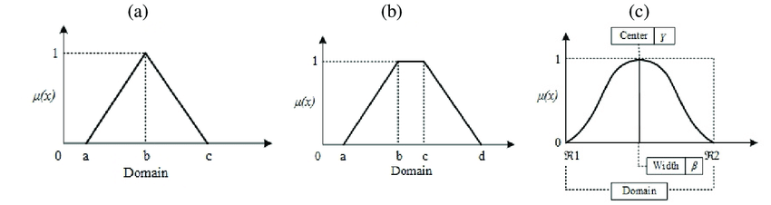

Fuzzy effort estimation:-

We take the input as size S, output as effort E, then a triangular fuzzy number, K(S), is defined as follows:

**0, S ≤0**

**S – α, a ≤ S ≤ m**

**K(S) = m-a**

**((β – S) / (β – m)), m ≤ S ≤ β**

**0, S >= β**

**Representation of k(s)**

K(S) = TFN (**α**, m, **β**), F=0.1

K(S) = TFN (**α**, m, **β**), F=0.2

K(S) = TFN (**α**, m, **β**), F=0.3

Where **α**, m and **β** are the parameter of the membership function, K(S), m is the model value, **α** and **β** are the right and left boundary respectively.

Let (m, 0) divides, internally, the base of the triangle in radio K**:** 1, where K is real positive number

So that m = **(α + K β) / (**K+1)

As by definition of fuzziness

**F** **=** (**β- α) / (2m)**

## So, α = (1-2kF/k+1)*m

**β = (1-2k/F+1)*m**

Gives values of **β** and **α** for **F** = 0.1, 0.2 and 0.3 for various values of k using, where m, size estimate in KDLOC.

Similarly, the TFN **μ** (**E**) is defined as,

**0, E <= a α b**

**((E/a) (1/b) - α / (m-a)), a α b** < **E**<**a m b**

**(β – (E/a) (1/b) / (β - m)), a m b** <**E**<**a β b**

**0, E>=a β b**

**μ** (E) = TFN (a **α** b, a m b, **β** b), F=0.1

**μ** (E) = TFN (a **α** b, a m b, **β** b), F=0.2

**μ** (E) = TFN (a **α** b, a m b, **β** b), F=0.3

|  |  |  |  |
| --- | --- | --- | --- |
| **F** | **K = 1** | **K = 2** | **K = 3** |
| 0.1 | **α =** 0.9m  **β =** 1.1m | **α = (**2.6/3**) \***m  **β = (**3.2/3**) \***m | **α =** 0.85m  **β =** 1.05m |
| 0.2 | **α =** 0.8m  **β =** 1.2m | **α = (**2.2/3**) \***m  **β = (**3.4/3**) \***m | **α =** 0.7m  **β =** 1.1m |
| 0.3 | **α =** 0.7m  **β =** 1.3m | **α =** 0.6m  **β =** 1.2m | **α =** 0.55m  **β =** 1.15m |

**Defuzzification:**

The single output, fuzzy estimate of E, can computed as a weighted average of the optimistic

Effort (E) = $\frac{wl\left(a a^{b}\right)+w2 \left(am^{b}\right)+w3 (ab^{b})}{w1+w2+w3}$

Where w1, w2 and w3 are weights of the optimistic, most likely and pessimistic estimate respectively. Maximum weight should be given to the most expected estimate.

**Proposed Model:**The single output, fuzzy estimate of E, can be computed as weighted average of the optimistic,

(a **α** b), most likely (a m b) and pessimistic estimate (a **β** b)

Effort E= $\frac{wl\left(a a^{b}\right)+w2 \left(am^{b}\right)+w3 (ab^{b})}{w1+w2+w3}$

Where w1, w2 and w3 are weights of the optimistic, most likely and pessimistic estimate respectively. Maximum weight should be given to the most expected estimate.

Where a=3.14, b=0.795 and m represents the size in KLOC

**α = (**1 - (2KF) / (K+1)**)** m

**β = (**1 + (2F) / (K+1)**)** m

Here K=1, F=0.2, w1=1, w2=10 and w3=10, **α** = 0.8m and **β** = 1.2m are arbitrary constants. The effort is estimated in man months (**MM**).

## ERROR ESTIMATION AND COMPARISION GRAPH

The performance of proposed software effort estimation model is evaluated by comparing against various software cost estimation models. All these models use MRE as evaluation criteria. So in order to make the estimation unbiased we intended to use MRE validation for comparison. The methodology used in empirical evaluation is described as follows:

* For each model, using MRE we evaluate the impact of estimation accuracy using (MRE, MARE) evaluation criteria.
* Criterion for measurement of software effort estimation model performance.

**Mean Absolute Relative Error (MARE):**

MMRE =1/N $\sum_{i=1}^{N}{}|E actual-E estimated |/Eactual$

Where, **E***i* – Estimated effort and **A***i* – Actual effort

**C:\Users\Ruhan Jacker\Desktop\aaaaaa.png**

Where estimate is the estimated from the model, actual is the actual effort and n is the number of projects.

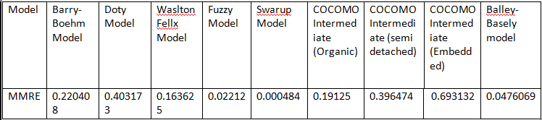

In this paper we proposed a model that performs better than other models in achieving the accuracy of effort estimation and can be known from the given set of test cases. We proposed fuzzy software cost estimation model that handles ambiguousness, obscurity and then compared with other popular software cost estimation models. From the empirical evaluation we concluded that: proposed fuzzy logic model showed better software effort estimate in view MMRE evaluation criteria as compared to the traditional estimation models. The above result demonstrate that applying fuzzy logic method to the software effort estimation is an expedient approach to addressing the problem of obscurity and vagueness existed in software effort drivers. Furthermore, the fuzzy logic model present better estimation accuracy as compared to other models. The utilization fuzzy logic for other application in the software engineering field can also be explored in the future.

**MODULES**

## 

**Modules**

1. **Welcome Page Module-**

* Create account
* Login to the system
* Navigation link for different purpose
* Calculate estimate

1. **Dashboard module**

* Quick access menu
* Logout
* Display MMRE chart
* Display Fuzzy v/s Actual graph

1. **User management Module(only for admin)**

* Display all the user information
* Delete the user

1. **User Profile Management Module**

* Edit user profile
* Update user password
* Update user avatar

1. **My Estimation Module**

* Display all the estimated project intimate (which is estimated by that user)
* Update the project estimation
* Delete the project estimation
* Add /change actual effort
* Display calculated in different model
* Show MMRE line chart specific project
* Show bar comparison chart for last estimated effort
* Show Fuzzy v/s Actual line chart or last ten estimation
* MMRE bar chart showing the for last ten estimation

**6. Calculate Estimate Module**

* Add estimation factor.
* Calculate and display effort by different model.
* Add project name KLOC in project description.

**CODING**

**Coding**

**1.Estimation Controller: Estimations.php**

**<?php**

**defined('BASEPATH') OR exit('No direct script access allowed');**

**class Estimations extends CI_Controller {**

**public function index()**

**{**

**$this->load->view('admin/Estimation');**

**}**

**public function add_Estimation()**

**{**

**$project_name=$this->input->post('project_name');**

**$project_kloc=$this->input->post('project_kloc');**

**$attr_rely=$this->input->post('rely');**

**$attr_data=$this->input->post('data');**

**$attr_cplx=$this->input->post('cplx');**

**$attr_time=$this->input->post('time');**

**$attr_stor=$this->input->post('stor');**

**$attr_virt=$this->input->post('virt');**

**$attr_turn=$this->input->post('turn');**

**$attr_acap=$this->input->post('acap');**

**$attr_aexp=$this->input->post('aexp');**

**$attr_pcap=$this->input->post('pcap');**

**$attr_vexp=$this->input->post('vexp');**

**$attr_modp=$this->input->post('modp');**

**$attr_tool=$this->input->post('tool');**

**$attr_sced=$this->input->post('sced');**

**$config = array(**

**array(**

**'field' => 'project_name',**

**'label' => 'Project Name',**

**'rules' => 'required'**

**),**

**array(**

**'field' => 'project_kloc',**

**'label' => 'Project KLOC',**

**'rules' => 'required'**

**)**

**);**

**$this->form_validation->set_rules($config);**

**if ($this->form_validation->run() == FALSE)**

**{**

**$arr['type']='error';**

**$arr['msg']=$this->form_validation->error_string();**

**exit(json_encode($arr));**

**}**

**else**

**{**

**$this->load->model('EstimationModel','um');**

**$result= $this->um->add($project_name,$project_kloc,$attr_rely,$attr_data,$attr_cplx,$attr_time,$attr_stor,$attr_virt,$attr_turn,$attr_acap,$attr_aexp,$attr_pcap,$attr_vexp,$attr_modp,$attr_tool,$attr_sced);**

**exit(json_encode($result));**

**}**

**}**

**public function fetch_Estimations()**

**{**

**$this->load->model('Estimationmodel','um');**

**$res= $this->um->fetch();**

**echo json_encode($res);**

**}**

**public function fetch_update()**

**{ $id=$this->input->post('user_id');**

**$this->load->model('Estimationmodel','um');**

**$res= $this->um->fetch_u($id);**

**echo json_encode($res);**

**}**

**public function update_Estimation()**

**{**

**$id=$this->input->post('image_id');**

**$project_name=$this->input->post('project_name');**

**$project_kloc=$this->input->post('project_kloc');**

**$attr_rely=$this->input->post('rely');**

**$attr_data=$this->input->post('data');**

**$attr_cplx=$this->input->post('cplx');**

**$attr_time=$this->input->post('time');**

**$attr_stor=$this->input->post('stor');**

**$attr_virt=$this->input->post('virt');**

**$attr_turn=$this->input->post('turn');**

**$attr_acap=$this->input->post('acap');**

**$attr_aexp=$this->input->post('aexp');**

**$attr_pcap=$this->input->post('pcap');**

**$attr_vexp=$this->input->post('vexp');**

**$attr_modp=$this->input->post('modp');**

**$attr_tool=$this->input->post('tool');**

**$attr_sced=$this->input->post('sced');**

**$config = array(**

**array(**

**'field' => 'project_name',**

**'label' => 'Project Name',**

**'rules' => 'required'**

**),**

**array(**

**'field' => 'project_kloc',**

**'label' => 'Project KLOC',**

**'rules' => 'required'**

**)**

**);**

**$this->form_validation->set_rules($config);**

**if ($this->form_validation->run() == FALSE)**

**{**

**$arr['type']='error';**

**$arr['msg']=$this->form_validation->error_string();**

**exit(json_encode($arr));**

**}**

**else**

**{**

**$this->load->model('EstimationModel','um');**

**$result= $this->um->update($id,$project_name,$project_kloc,$attr_rely,$attr_data,$attr_cplx,$attr_time,$attr_stor,$attr_virt,$attr_turn,$attr_acap,$attr_aexp,$attr_pcap,$attr_vexp,$attr_modp,$attr_tool,$attr_sced);**

**exit(json_encode($result));**

**}**

**}**

**public function delete_Estimation()**

**{ $id=$this->input->post('delete_id');**

**$this->load->model('Estimationmodel','um');**

**$result= $this->um->delete($id);**

**exit(json_encode($result));**

**}}**

**2.Estimation Model: EstimationModel.php**

**<?php**

**defined('BASEPATH') OR exit('No direct script access allowed');**

**class EstimationModel extends CI_Model**

**{**

**Public function add($project_name,$project_kloc,$attr_rely,$attr_data,$attr_cplx,$attr_time,$attr_stor,$attr_virt,$attr_turn,$attr_acap,$attr_aexp,$attr_pcap,$attr_vexp,$attr_modp,$attr_tool,$attr_sced)**

**{**

**$logged_id=$this->session->user_id;**

**// Basic COCOCMO calc star if($project_kloc < 50 )**

**{**

**$basic_effort=2.4*(pow($project_kloc,1.05));**

**}**

**else if($project_kloc >= 50 AND $project_kloc <= 150)**

**{**

**$basic_effort=3.0*(pow($project_kloc,1.12));**

**}**

**else**

**{**

**$basic_effort=3.6*(pow($project_kloc,1.20));**

**}**

**// Basic COCOCMO calc end**

**// Inter COCOMO**

**$eaf=$attr_rely*$attr_data*$attr_cplx*$attr_time*$attr_stor*$attr_virt*$attr_turn*$attr_acap*$attr_aexp*$attr_pcap*$attr_vexp*$attr_modp*$attr_tool*$attr_sced;**

**if($project_kloc < 50 )**

**{**

**$inter_effort=3.2*(pow($project_kloc,1.06));**

**}**

**else if($project_kloc >= 50 AND $project_kloc <= 150)**

**{**

**$inter_effort=3.0*(pow($project_kloc,1.12));**

**}**

**else**

**{**

**$inter_effort=2.8*(pow($project_kloc,1.20));**

**}**

**$inter_effort=$inter_effort*$eaf;**

**// Halsted Model Start**

**$halsted_effort=(5.2*(pow($project_kloc,1.50)));**

**$halsted_effort=$halsted_effort*$eaf;**

**// Halsted Model End**

**// Baiely Model Start**

**$baiely_effort=5.5+ (0.73*(pow($project_kloc,1.16)));**

**$baiely_effort=$baiely_effort*$eaf;**

**// Baiely Model End**

**// Doty Model Start**

**$doty_effort=(5.288*(pow($project_kloc,1.047)));**

**$doty_effort=$doty_effort*$eaf;**

**// Doty Model End**

**// Fuzy Model Start**

**$alpha=.7*$project_kloc;**

**$beta=1.3*$project_kloc;**

**$fuzzy_effort=( (1*(6*pow($alpha,.665))) + (4*(6*pow($project_kloc,.665))) + (1*(6*pow($alpha,.665))) )/(6);**

**$fuzzy_effort=$fuzzy_effort*$eaf;**

**// Fuzy Model End $array=array($basic_effort,$inter_effort,$halsted_effort,$baiely_effort,$doty_effort,$fuzzy_effort);**

**$data=['user_id'=>"$logged_id",'project_name'=>"$project_name",'project_kloc'=>"$project_kloc",'cocomo_basic_effort'=>"$basic_effort",'cocomo_inter_effort'=>"$inter_effort",'halsted_effort'=>"$halsted_effort",'baiely_effort'=>"$baiely_effort",'doty_effort'=>"$doty_effort",'fuzzy_model_effort'=>"$fuzzy_effort",'status'=>'0'];**

**$query=$this->db**

**->insert('Projects',$data);**

**if($this->db->affected_rows())**

**{**

**$arr['type']='success';**

**$arr['msg']="Estimation Created Successfully";**

**$arr['result']=$array;**

**return $arr;**

**}**

**else**

**{**

**$arr['type']='error';**

**$arr['msg']='Error Occured';**

**return $arr;**

**}**

**}**

**public function update($id,$project_name,$project_kloc,$attr_rely,$attr_data,$attr_cplx,$attr_time,$attr_stor,$attr_virt,$attr_turn,$attr_acap,$attr_aexp,$attr_pcap,$attr_vexp,$attr_modp,$attr_tool,$attr_sced)**

**{**

**$logged_id=$this->session->user_id;**

**// Basic COCOCMO calc start**

**if($project_kloc < 50 )**

**{**

**$basic_effort=2.4*(pow($project_kloc,1.05));**

**}**

**else if($project_kloc >= 50 AND $project_kloc <= 150)**

**{**

**$basic_effort=3.0*(pow($project_kloc,1.12));**

**}**

**else**

**{**

**$basic_effort=3.6*(pow($project_kloc,1.20));**

**}**

**// Basic COCOCMO calc end**

**// Inter COCOMO**

**$eaf=$attr_rely*$attr_data*$attr_cplx*$attr_time*$attr_stor*$attr_virt*$attr_turn*$attr_acap*$attr_aexp*$attr_pcap*$attr_vexp*$attr_modp*$attr_tool*$attr_sced;**

**if($project_kloc < 50 )**

**{**

**$inter_effort=3.2*(pow($project_kloc,1.06));**

**}**

**else if($project_kloc >= 50 AND $project_kloc <= 150)**

**{**

**$inter_effort=3.0*(pow($project_kloc,1.12));**

**}**

**else**

**{**

**$inter_effort=2.8*(pow($project_kloc,1.20));**

**}**

**$inter_effort=$inter_effort*$eaf;**

**// Halsted Model Start**

**$halsted_effort=(5.2*(pow($project_kloc,1.50)));**

**$halsted_effort=$halsted_effort*$eaf;**

**// Halsted Model End**

**// Baiely Model Start**

**$baiely_effort=5.5+ (0.73*(pow($project_kloc,1.16)));**

**$baiely_effort=$baiely_effort*$eaf;**

**// Baiely Model End**

**// Doty Model Start**

**$doty_effort=(5.288*(pow($project_kloc,1.047)));**

**$doty_effort=$doty_effort*$eaf;**

**// Doty Model End**

**// Fuzy Model Start**

**$alpha=.7*$project_kloc;**

**$beta=1.3*$project_kloc;**

**$fuzzy_effort=( (1*(6*pow($alpha,.665))) + (4*(6*pow($project_kloc,.665))) + (1*(6*pow($alpha,.665))) )/(6);**

**$fuzzy_effort=$fuzzy_effort*$eaf;**

**// Fuzy Model End**

**$array=array($basic_effort,$inter_effort,$halsted_effort,$baiely_effort,$doty_effort,$fuzzy_effort);**

**$data=['project_name'=>"$project_name",'project_kloc'=>"$project_kloc",'cocomo_basic_effort'=>"$basic_effort",'cocomo_inter_effort'=>"$inter_effort",'status'=>'0'];**

**$array1=['id'=>"$id"];**

**$query=$this->db**

**->where($array1)**

**->update('projects',$data);**

**if($this->db->affected_rows())**

**{**

**$arr['type']='success';**

**$arr['msg']="Estimation Created Successfully";**

**$arr['result']=$array;**

**return $arr;**

**}**

3.My Estimation controller:Records.php

<?php

defined('BASEPATH') OR exit('No direct script access allowed');

class Records extends CI_Controller

{

public function index()

{

$this->load->view('admin/records');

}

public function fetch_records()

{

$this->load->model('RecordModel','pm');

$this->load->library("pagination");

$config = array();

$config["base_url"] = "http://localhost/Fianl_year/Records/";

$config["total_rows"] = $this->pm->count_all();

$config["per_page"] = 7;

$config["uri_segment"] = 3;

$config["use_page_numbers"] = TRUE;

$config["full_tag_open"] = '<ul class="pagination pagination-circle pg-danger mb-0">';

$config["full_tag_close"] = '</ul>';

$config["first_tag_open"] = '<li class="page-item page-link active">';

$config["first_tag_close"] = '</li>';

$config["last_tag_open"] = '<li class="page-item page-link">';

$config["last_tag_close"] = '</li>';

$config['next_link'] = '&gt;';

$config["next_tag_open"] = '<li class="page-item page-link">';

$config["next_tag_close"] = '</li>';

$config["prev_link"] = "&lt;";

$config["prev_tag_open"] = "<li class='page-item page-link'>";

$config["prev_tag_close"] = "</li>";

$config["cur_tag_open"] = "<li class='page-item active'><a href='#' class='page-link'>";

$config["cur_tag_close"] = "</a></li>";

$config["num_tag_open"] = "<li class='page-item page-link'>";

$config["num_tag_close"] = "</li>";

$config["num_links"] = 1;

$this->pagination->initialize($config);

$page = $this->uri->segment(3);

$start = ($page - 1) * $config["per_page"];

$res= $this->pm->fetch($config["per_page"], $start);

if ($res['type']=='success')

{

$x=1;

$output="";

for ($i = 0; $i <count($res['msg']); $i++)

{

$output.="<tr>";

$output.="<td>".$x."</td>";

$output.="<td>".$res['msg'][$i]['date']."</td>";

$output.="<td>".$res['msg'][$i]['project_name']."</td>";

$output.="<td>".$res['msg'][$i]['project_kloc']."</td>";

$output.="<td>".$res['msg'][$i]['cocomo_basic_effort']."</td>";

$output.="<td>".$res['msg'][$i]['cocomo_inter_effort']."</td>";

$output.="<td>".$res['msg'][$i]['fuzzy_model_effort']."</td>";

$output.= "<td class='text-center'>";

$output.="<button class='btn btn-sm btn-white mmre_single' data-id='".$res['msg'][$i]['id']."' ><i class='fa fa-clock' ></i></a>";

$output.="<button type='button' name='update' data-id='".$res['msg'][$i]['id']."' data-name='".$res['msg'][$i]['project_name']."' data-kloc='".$res['msg'][$i]['project_kloc']."' class='btn btn-success btn-sm update_call my-0' data-what='update_user'><i class='fa fa-pen' ></i></button>";

$output.="<button type='button' name='actual' data-id='".$res['msg'][$i]['id']."' data-actual='".$res['msg'][$i]['actual_effort']."' class='btn btn-white btn-sm actual_call my-0' data-what='update_actual'>A</button>";

$output.="<button class='btn btn-danger delete_call btn-sm my-0'data-what='delete_user' data-id='".$res['msg'][$i]['id']."'><i class='fa fa-times' ></i></button></td>"

;

$output.="</tr>";

$x++;

}

$output.=" ";

}

else if($res['type']=='error')

{

$output="<h3 class='text-center'>No Record Found</h3>";

}

$arr['pagination_link']=$this->pagination->create_links();

$arr['table']=$output;

// $arr['msg']='w';

// $arr['success']='d';

exit(json_encode($arr));

}

public function fetch_update()

{ $id=$this->input->post('user_id');

$this->load->model('Usermodel','um');

$res= $this->um->fetch_u($id);

echo json_encode($res);

}

public function fetch_total()

{ $id=$this->input->post('id');

$this->load->model('RecordModel','um');

$res= $this->um->total($id);

for ($i=0; $i <count($res['msg']) ; $i++)

{

$kloc[]=$res['msg'][$i]['project_kloc'];

$cocomo_basic_effort[]=$res['msg'][$i]['cocomo_basic_effort'];

$cocomo_inter_effort[]=$res['msg'][$i]['cocomo_inter_effort'];

$halsted_effort[]=$res['msg'][$i]['halsted_effort'];

$doty_effort[]=$res['msg'][$i]['doty_effort'];

$baiely_effort[]=$res['msg'][$i]['baiely_effort'];

$fuzzy_model_effort[]=$res['msg'][$i]['fuzzy_model_effort'];

$actual_effort[]=$res['msg'][$i]['actual_effort'];

}

$res1=array('kloc'=>$kloc,'cocomo_basic'=>$cocomo_basic_effort,'cocomo_inter'=>$cocomo_inter_effort,'halsted'=>$halsted_effort,'doty'=>$doty_effort,'baiely'=>$baiely_effort, 'fuzzy'=>$fuzzy_model_effort,'actual'=>$actual_effort);

echo json_encode($res1);

}

public function fetch_mmre()

{

$this->load->model('RecordModel','um');

$id= $this->input->post('id');

$res= $this->um->total($id);

$cocomo_bsum=0;$cocomo_isum=0;$halsted_bsum=0;$doty_bsum=0;$baiely_bsum=0;$fuzzy_bsum=0;

for ($i=0; $i <count($res['msg']) ; $i++)

{

$kloc[]=$res['msg'][$i]['project_kloc'];

$cocomo_basic_mmre=(abs($res['msg'][$i]['cocomo_basic_effort'] - $res['msg'][$i]['actual_effort']) / $res['msg'][$i]['actual_effort']);

$cocomo_bsum=$cocomo_bsum + $cocomo_basic_mmre;

$cocomo_inter_mmre=(abs($res['msg'][$i]['cocomo_basic_effort'] - $res['msg'][$i]['actual_effort'])/ $res['msg'][$i]['actual_effort']);

$cocomo_isum=$cocomo_isum + $cocomo_inter_mmre;

$halsted_mmre=(abs($res['msg'][$i]['halsted_effort'] - $res['msg'][$i]['actual_effort'])/ $res['msg'][$i]['actual_effort']);

$halsted_bsum=$halsted_bsum + $halsted_mmre;

$baiely_mmre=(abs($res['msg'][$i]['baiely_effort'] - $res['msg'][$i]['actual_effort'])/ $res['msg'][$i]['actual_effort']);

$baiely_bsum=$baiely_bsum + $baiely_mmre;

$doty_mmre=(abs($res['msg'][$i]['doty_effort'] - $res['msg'][$i]['actual_effort'])/ $res['msg'][$i]['actual_effort']);

$doty_bsum=$doty_bsum + $doty_mmre;

$fuzzy_mmre=(abs($res['msg'][$i]['fuzzy_model_effort'] - $res['msg'][$i]['actual_effort'])/ $res['msg'][$i]['actual_effort']);

$fuzzy_bsum=$fuzzy_bsum + $fuzzy_mmre;

}

if(!isset($id))

{

$cocomo_basic_mmre=($cocomo_bsum /10);

$cocomo_inter_mmre=($cocomo_isum /10);

$halsted_mmre=($halsted_bsum /10);

$doty_mmre=($doty_bsum /10);

$baiely_mmre=($baiely_bsum /10);

$fuzzy_mmre=($fuzzy_bsum /10);

}

else

{

$cocomo_basic_mmre=($cocomo_bsum);

$cocomo_inter_mmre=($cocomo_isum);

$halsted_mmre=($halsted_bsum);

$doty_mmre=($doty_bsum);

$baiely_mmre=($baiely_bsum);

$fuzzy_mmre=($fuzzy_bsum);

}

$res1=array($cocomo_basic_mmre,$cocomo_inter_mmre,$baiely_mmre,$doty_mmre,$halsted_mmre,$fuzzy_mmre);

echo json_encode($res1);

}

public function update_record()

{

$name=$this->input->post('name');

$mobile=$this->input->post('mobile');

$email=$this->input->post('email');

$id=$this->input->post('image_id');

$config = array(

array(

'field' => 'name',

'label' => 'Name',

'rules' => 'required'

),

array(

'field' => 'mobile',

'label' => 'Moile',

'rules' => 'required'

),

array(

'field' => 'email',

'label' => 'Email',

'rules' => 'required|valid_email'

$this->form_validation->set_rules($config);

if ($this->form_validation->run() == FALSE)

{

$arr['type']='error';

$arr['msg']=$this->form_validation->error_string();

exit(json_encode($arr));

}

else

{

$this->load->model('Usermodel','um');

$result= $this->um->update($name,$email,$mobile,$id);

exit(json_encode($result));

}

}

public function update_actual()

{

$actual_effort=$this->input->post('actual_effort');

$id=$this->input->post('delete_id');

$config = array(

array(

'field' => 'actual_effort',

'label' => 'Actual Effort',

'rules' => 'required'

$this->form_validation->set_rules($config);

if ($this->form_validation->run() == FALSE)

{

$arr['type']='error';

$arr['msg']=$this->form_validation->error_string();

exit(json_encode($arr));

}

else

{

$this->load->model('Recordmodel','um');

$result= $this->um->update_actual($actual_effort,$id);

exit(json_encode($result));

}

}

public function delete_record()

{ $id=$this->input->post('delete_id');

$this->load->model('RecordModel','um');

$result= $this->um->delete($id); exit(json_encode($result)); }}

4.My Estimation Model:RecordModel.php

<?php

defined('BASEPATH') OR exit('No direct script access allowed');

class RecordModel extends CI_Model

{

public function count_all()

{

$logged_id=$this->session->user_id;

$query=$this->db

->where('status !=','1')

->where('user_id',"$logged_id")

->select(['id'])

->get('projects');

return $query->num_rows();

}

public function total($id)

{

$logged_id=$this->session->user_id;

if(isset($id))

{

$query=$this->db

->where('status !=','1')

->where('id',"$id")

->where('user_id',"$logged_id")

->select(['project_kloc','actual_effort','cocomo_basic_effort','cocomo_inter_effort','halsted_effort','doty_effort','baiely_effort','fuzzy_model_effort'])

->get('projects');

}

else

{

$query=$this->db

->where('status !=','1')

->where('user_id',"$logged_id")

->select(['project_kloc','actual_effort','cocomo_basic_effort','cocomo_inter_effort','halsted_effort','doty_effort','baiely_effort','fuzzy_model_effort'])

->order_by('id','DESC')

->get('projects',10);

}

if(($query->num_rows()))

{

$res=$query->result_array();

$arr['type']='success';

$arr['msg']=$res;

return $arr;

}

}

public function mmre()

{

$logged_id=$this->session->user_id;

$query=$this->db

->where('status !=','1')

->where('user_id',"$logged_id")

->select(['project_kloc','actual_effort','cocomo_basic_effort','cocomo_inter_effort','halsted_effort','doty_effort','baiely_effort','fuzzy_model_effort'])

->order_by('id','DESC')

->get('projects',10);

if(($query->num_rows()))

{

$res=$query->result_array();

$arr['type']='success';

$arr['msg']=$res;

return $arr;

}

}

public function fetch($limit,$start)

{

$logged_id=$this->session->user_id;

$query=$this->db

->where('status','0')

->where('user_id',"$logged_id")

->select(['id','user_id','date','project_name','project_kloc','cocomo_basic_effort','cocomo_inter_effort','fuzzy_model_effort','actual_effort'])

->order_by('id','DESC')

->get('projects',$limit,$start);

if(($query->num_rows()))

{

$res=$query->result_array();

$arr['type']='success';

$arr['msg']=$res;

return $arr;

}

else

{

$arr['type']='error';

$arr['mag']="No Record Found1";

return $arr;

}

}

public function fetch_u($id)

{

$query=$this->db

->where('id',"$id")

->select(['name','mobile','email'])

->get('projects');

if(($query->num_rows()))

{

$res=$query->result_array();

return $res;

}

else

{

return 'No result found';

}

}

public function update($name,$email,$mobile,$id)

{

$data=['name'=>"$name",'email'=>"$email",'mobile'=>"$mobile"];

$array=['id'=>"$id"];

$query=$this->db

->where($array)

->update('projects',$data);

if($this->db->affected_rows())

{

$arr['type']='success';

$arr['msg']="Record Updated Successfully";

return $arr;

}

else

{

$arr['type']='error';

$arr['msg']="Error Occured";

return $arr;

}

}

}

public function delete($id)

{

$data=['status'=>"1"];

$array=['id'=>"$id"];

$query=$this->db

->where($array)

->update('projects',$data);

if($this->db->affected_rows())

{

$arr['type']='success';

$arr['msg']="Record Deleted Successfully";

return $arr;

}

else

{

$arr['type']='error';

$arr['msg']="$id";

return $arr;

**IMPLEMENTATION**

**&**

**SNAPSHOTS**

**IMPLEMATION & SNAPSHOTS**

WELCOME PAGES





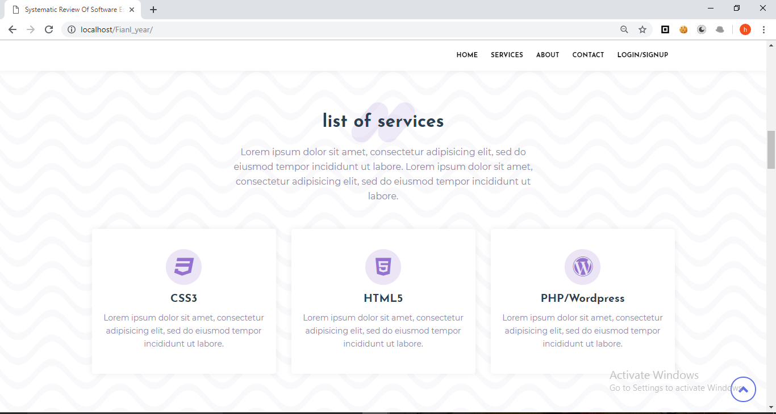



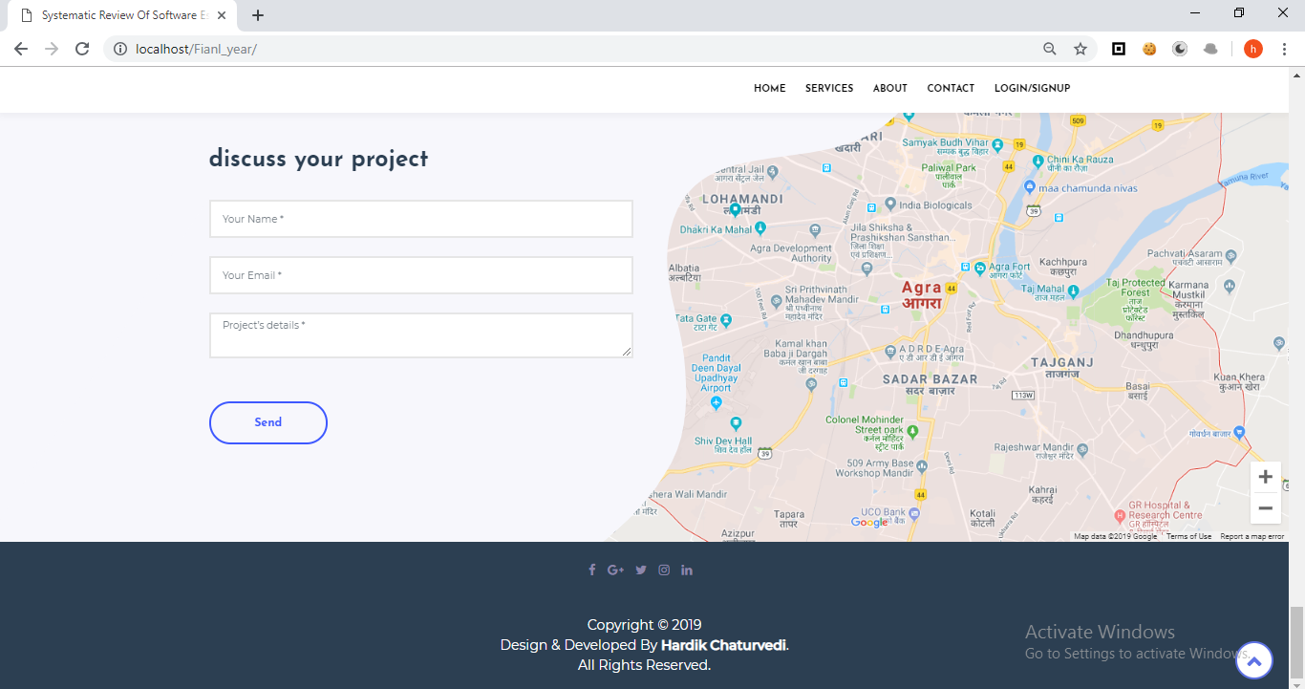

LOGIN PAGE

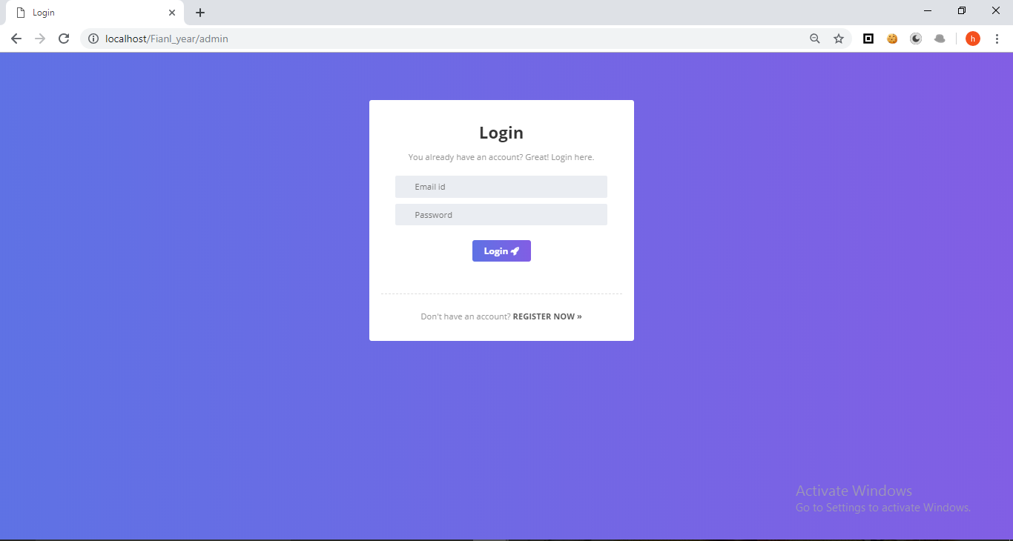

SIGNUP PAGE

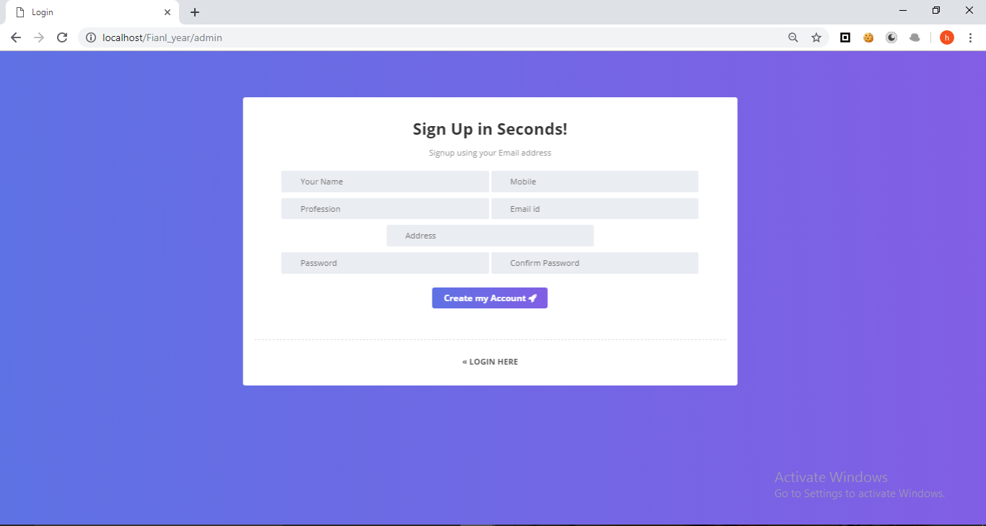

DASHBOARD

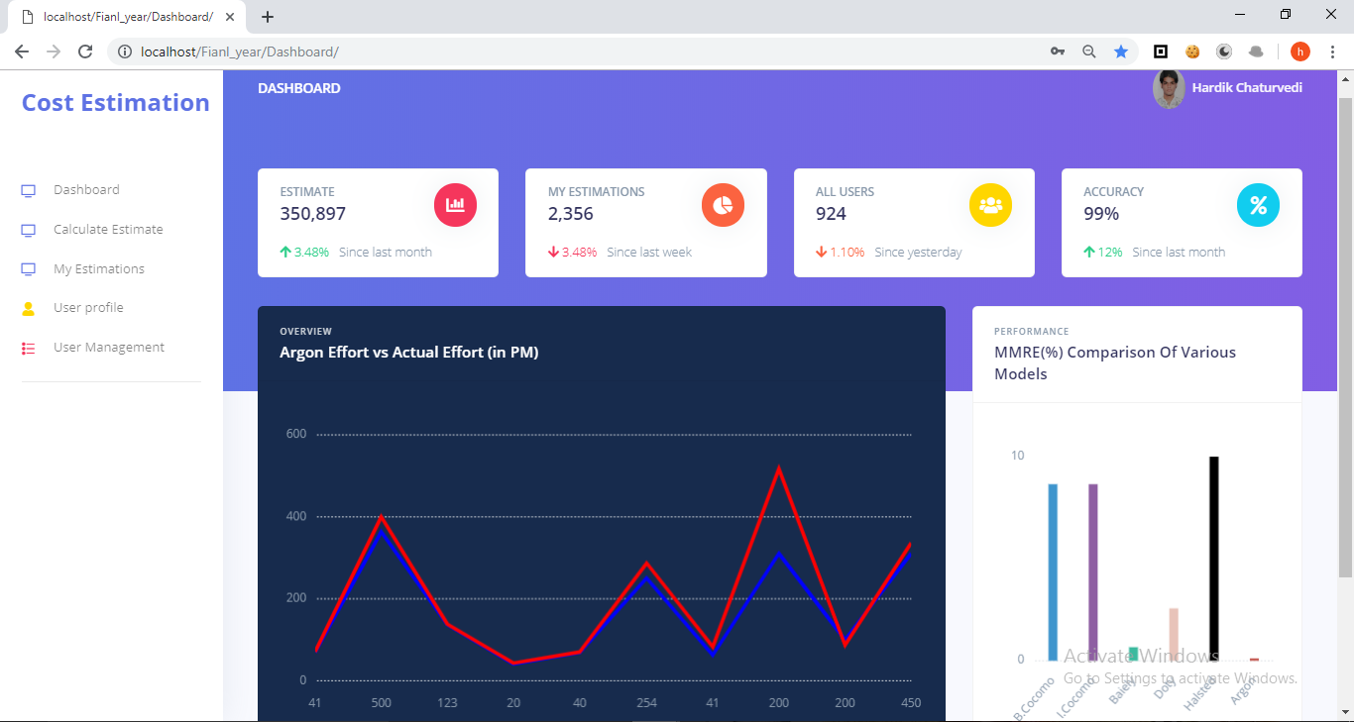

ESTIMATION PAGES

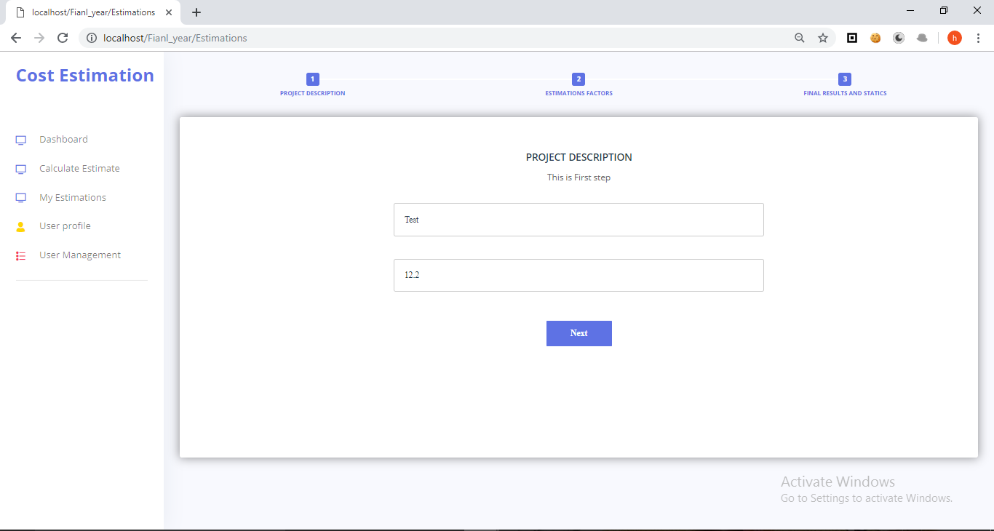

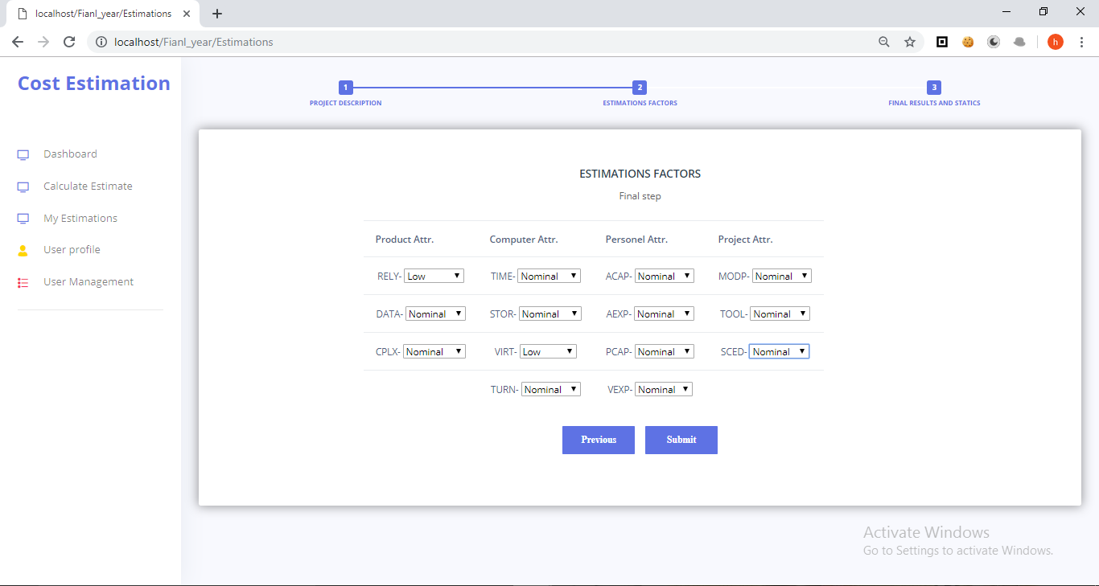

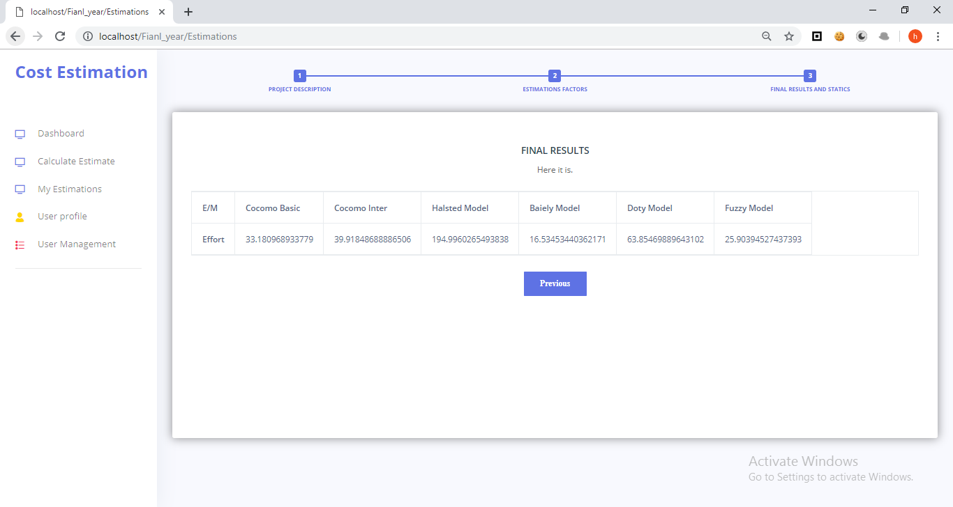

MY ESTIMATION PAGES

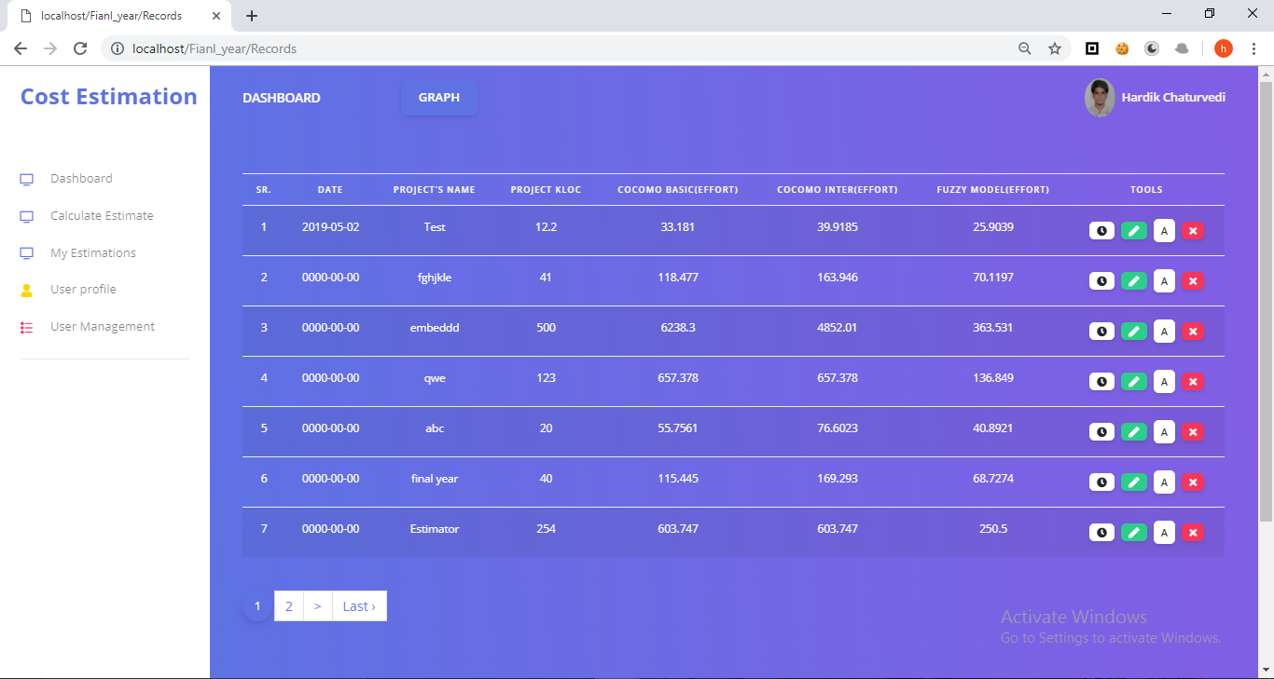

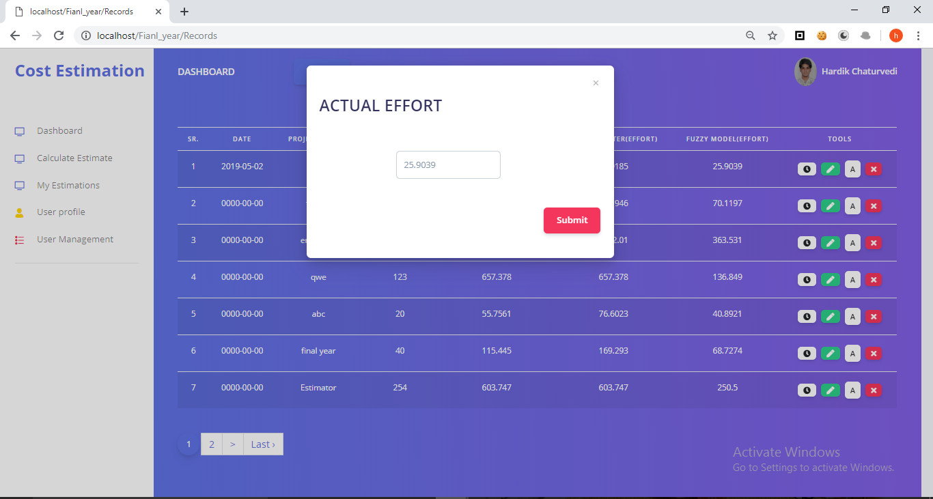

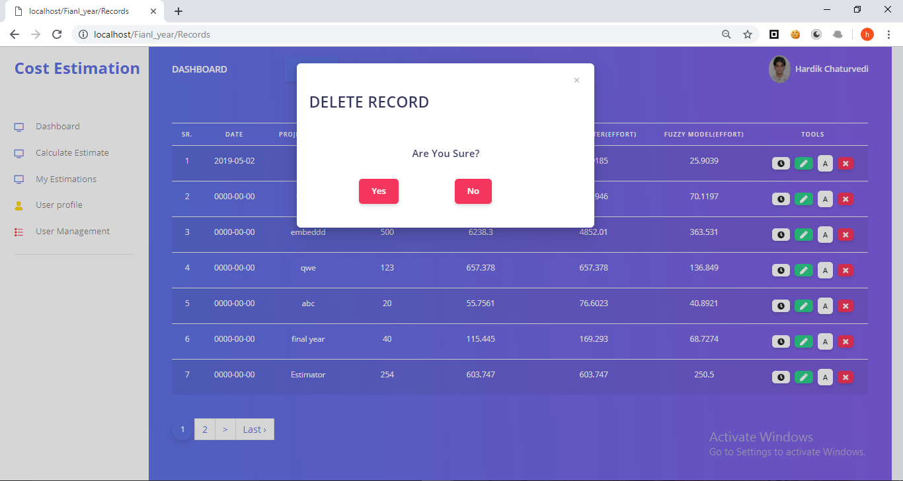

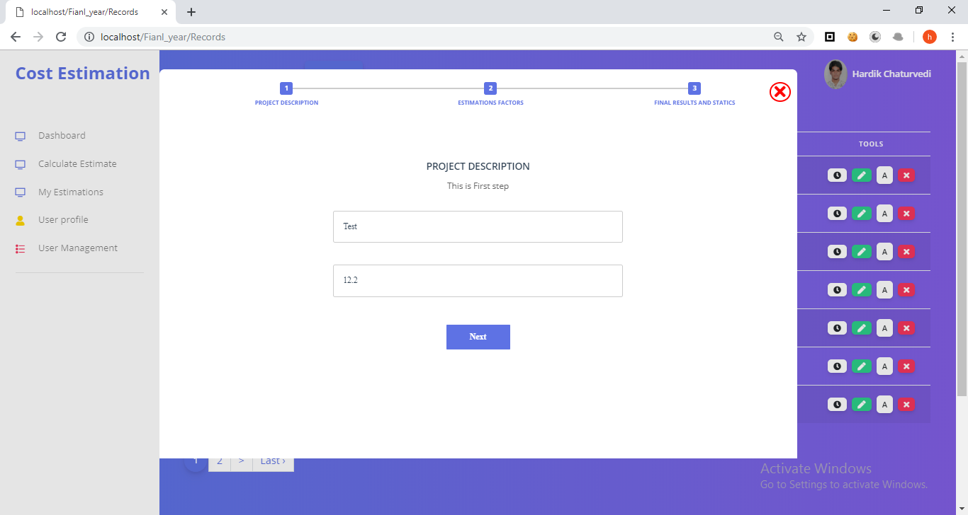

USERS PAGE

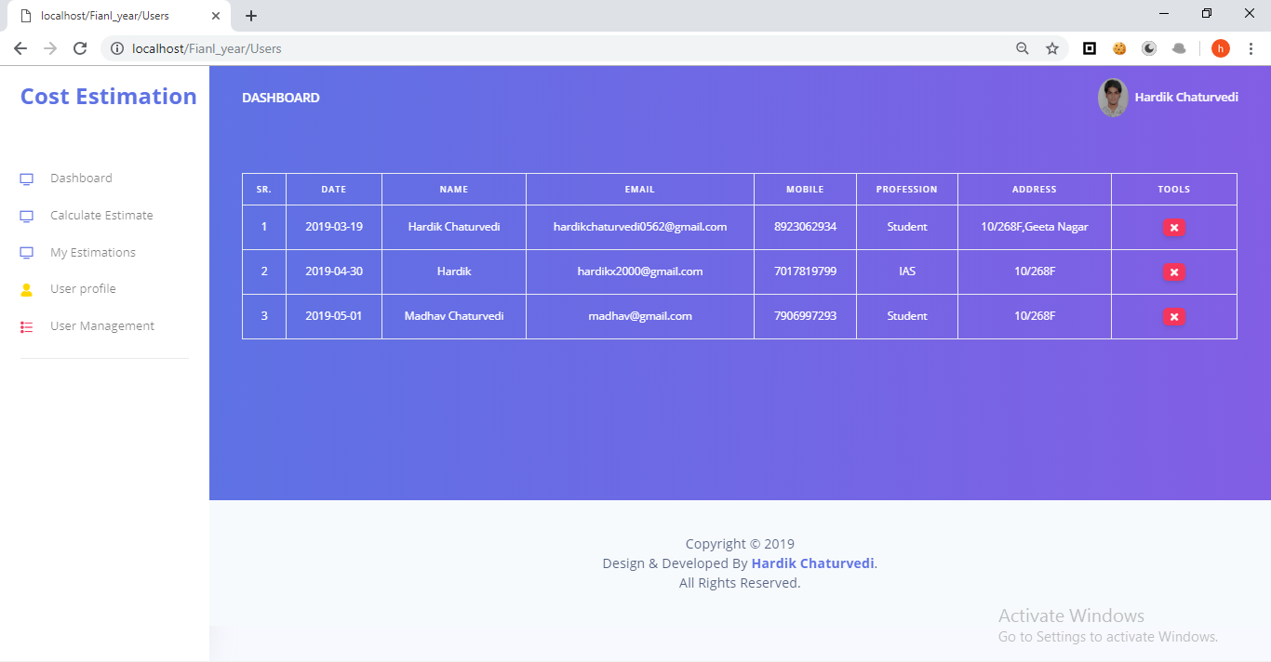

DATABASE TABLES

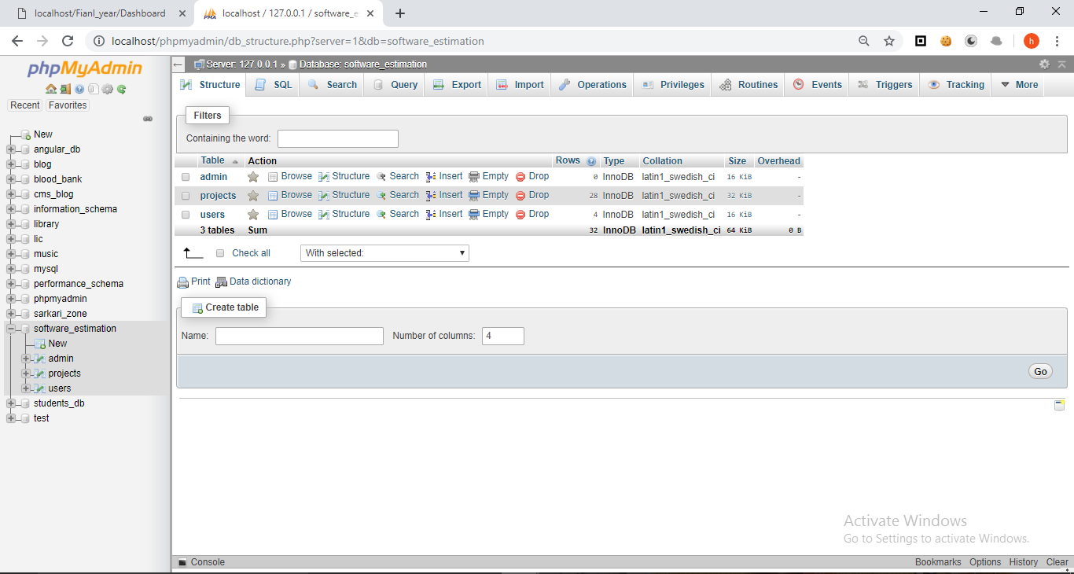

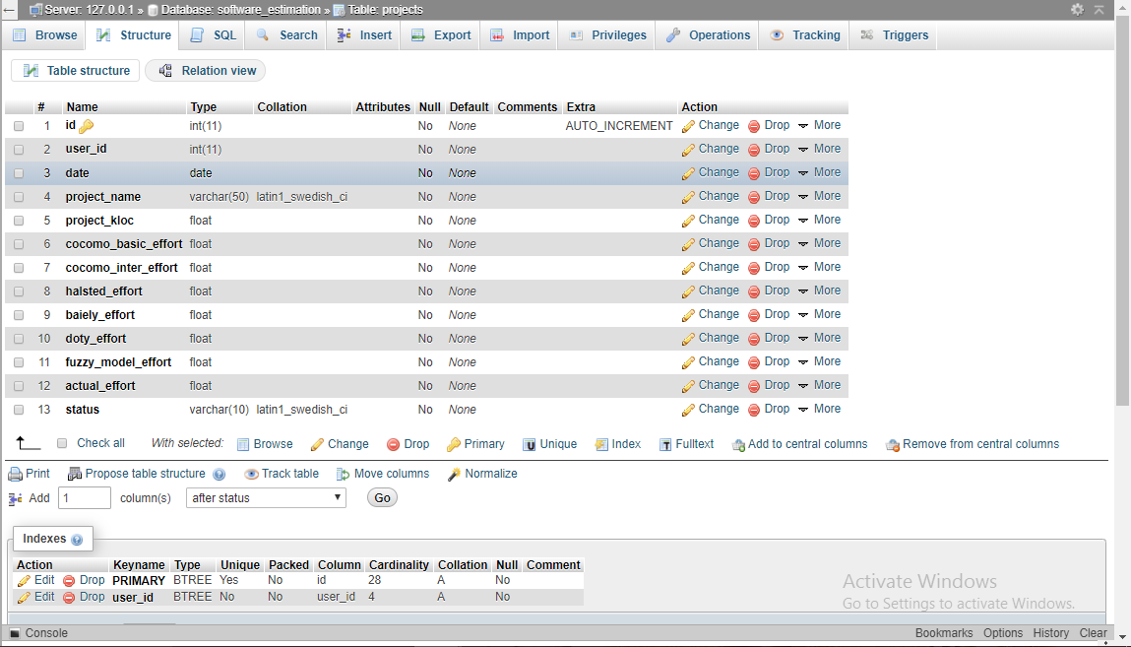

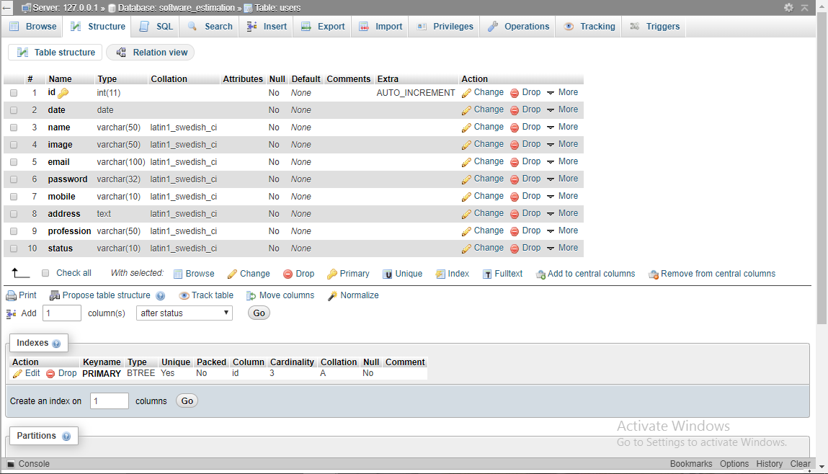

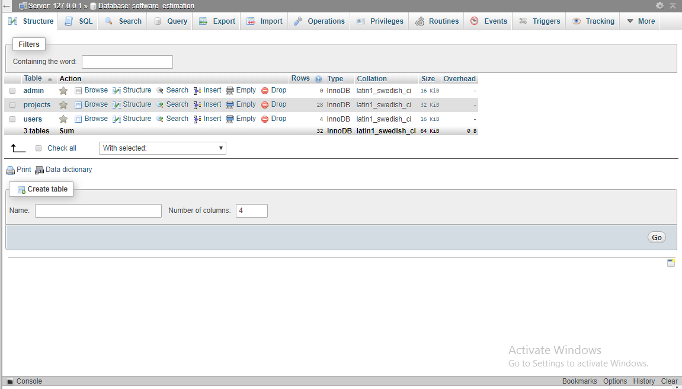

**Results & Conclusion**

## 

## 

## RESULTS AND CONCLUSION

In this project we estimated the effort using various model such as COCOMO Intermediate (Organic, Semidetached), Bailey-Basili, Barry-Bohem, Doty, Halsted. Author also used the fuzzy technique for the estimation. As we known choice of estimation method and level of accuracy depends on many factors and the information associated with projects. It is absolutely necessary to use more than one method of estimation and analyze the values for decision making. Authors use the fuzzy model and one of the proposed models. This paper also contains the two comparison graphs, first graph shows the comparison between fuzzy model 1 and Swarup model, author graph shows the comparison among various effort estimation models.

GRAPH ALL COMAPRISON

# *C:\Users\Hardik\Desktop\Shots\gra1.PNG*

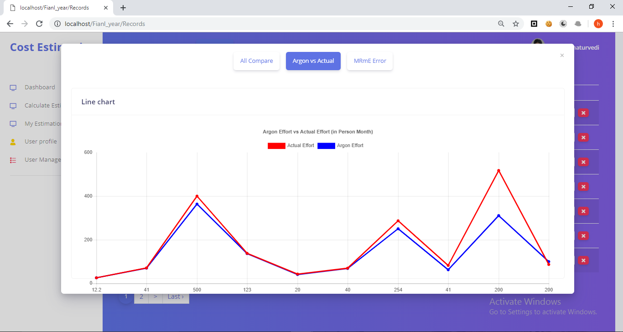

# *C:\Users\Hardik\Desktop\Shots\gra3.PNG*

SINGLE MMRE

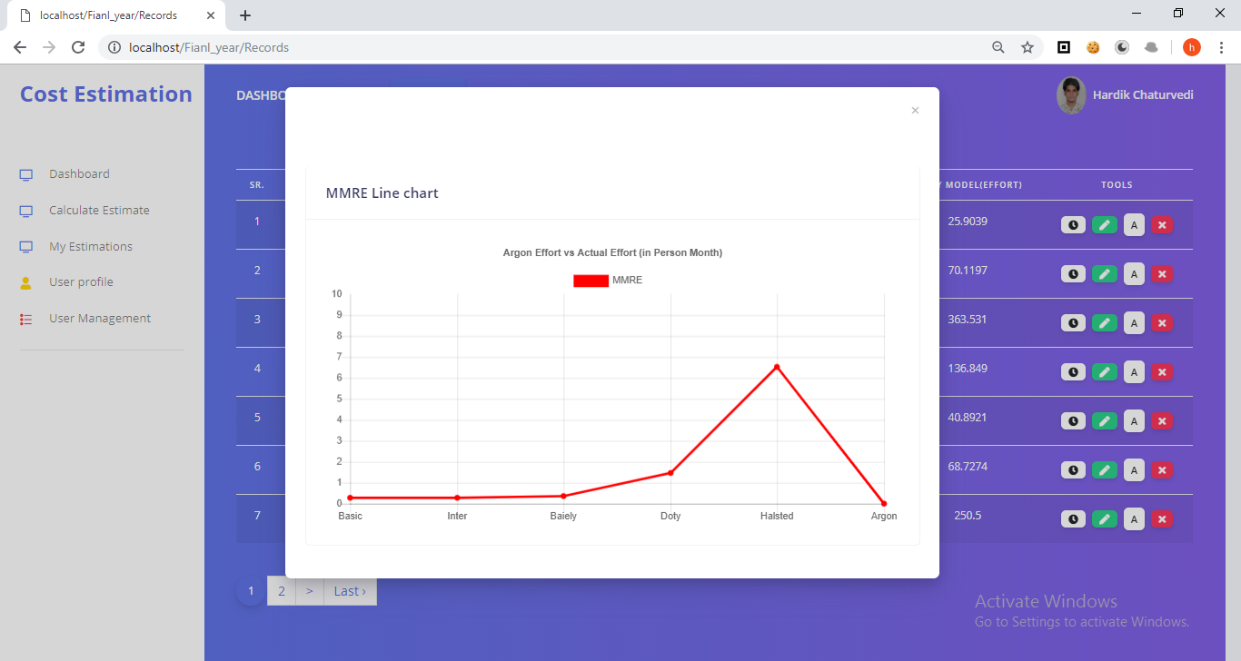

RECORD



ACTUAL EFFORT



**Future Aspects**

**FUTURE ASPECTS**

The future approach to us we implement the effort using **transection** based use case approach and optimize various model such as COCOMO Intermediate (Organic, Semidetached, Embedded), Bailey-Basili, Barry-Bohem, Doty, Waslton Felix. Authors taken various project details and then estimated the effort by using various models. Author also used the fuzzy technique for the estimation. As we known choice of estimation method and level of accuracy depends on many factors and the information associated with projects. It is absolutely necessary to use more than one method of estimation and analyze the values for decision making. Authors use the fuzzy model and one of the proposed models. This paper also contains the two comparison graphs, first graph shows the comparison between fuzzy model 1 and Swarup model, author graph shows the comparison among various effort estimation models.

**Bibliography**

## Bibliography

* A . Sheta, “Estimation of the COCOMO Model Parameters Using Genetic Algorithms for NASA Software Projects”, Journal of Computer Science, vol. 2, no. 2, (2006), pp. 118-123.
* A. J. Albrecht, “ easuring application development productivity”, SHAR /GUID IB Application development Symposium.
* A. S. Andreou and E. Papatheocharous, “Software Cost Estimation using uzzy Decision Trees”, in 23rd IEEE/ACM International Conference on Automated Software Engineering, (2008), pp. 371-374.
* I. Attarzadeh and S. Hockow, “Improving the Accuracy of Software Cost Estimation Model Based on a New Fuzzy Logic Model”, World Applied Sciences Journal, vol. 8, no. 2, (2010), pp. 177-184.
* J. W. Bailey and Basili, “A eta model for software development resource expenditure”, Proc. Intl. Conf. Software Engineering, (1981), pp. 107-115.
* L. A. Zadeh, “ uzzy Sets, Information and Control”, vol. 8, (1965), pp. 338-353.